Design Approach & Assumptions Document by VIKRAM KUMAR
Ground Box & Steel Cover - SOLIDWORKS 2025
For this assessment, I modeled the Ground Box and Steel Cover assembly in SOLIDWORKS 2025 based on the provided engineering drawing.
Design Approach & Thought Process
Before starting 3D modeling, I first analyzed the DWG layout. I followed a sequence of General Assembly, then Assembly, then Sub-Assembly, individual Parts, and Drifting details. This helped me understand how all components fit together. After understanding the layout, I started modeling individual parts and then created the final assembly. I ensured that the cover opens and closes properly by applying correct mates and constraints in the assembly environment.
Software Features Used & Justification
I used the Sheet Metal feature for all bent and folded plate components of the ground box and cover because it gives accurate flat pattern and bend allowance.
For structural members, I used the Weldment feature for L Angle and Rectangular Tube sections. Weldment is the best choice for frame structures as it helps to manage structural profiles and automatically generates a cut list. Other tools used were Feature, Sketch, Assembly, and Drifting.Assumptions Made
Some dimensions were not clearly mentioned in the drawing. For those, I assumed standard industry practices for ground box design. The thickness of plates, size of hinges, and locking mechanism were taken as per standard TxDOT ground box specifications. I assumed steel as the material for all parts.
(All dimension in Inches)
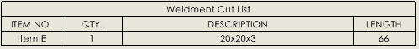

BOM(Solidworks):
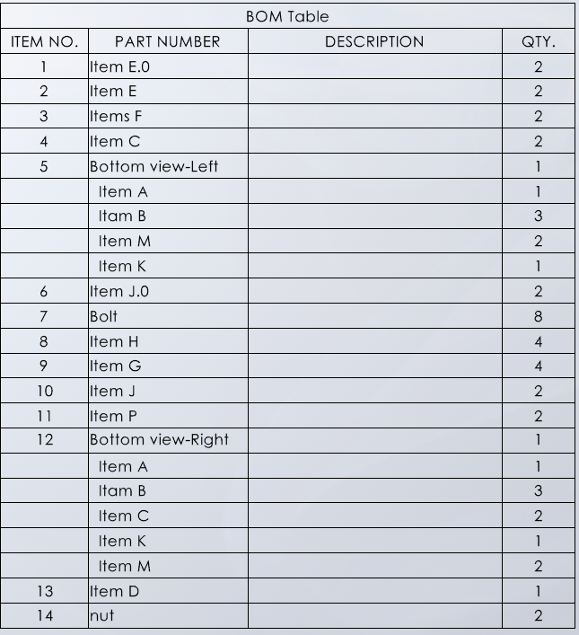
Challenges Faced & Solutions
During 3D modeling, I faced 2 main issues. Item J was missing in the initial layout. As per BOM, Item J quantity is 4. Two pieces are on the front side and two on the opposite side. Due to this opposite position, the extrude direction of Item J was changing. I corrected it by creating mirrored features as per assembly requirement.
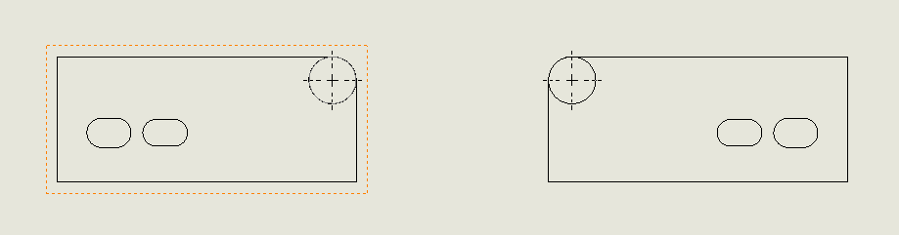

Floor Plate issue:
I saved the floor plate with two different part names. The Length and Width of both plates are the same, but due to opposite orientation, the direction of the rectangular hole was changing. I fixed this by applying correct orientation and reference planes in the assembly. I did not face much difficulty overall because I am familiar with SOLIDWORKS tools.
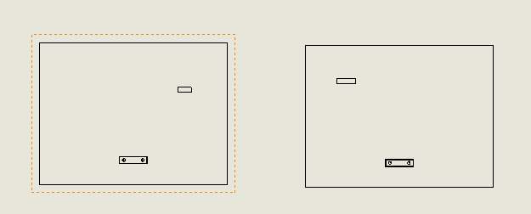

FEA Analysis - AASHTO H-20 Loading
Note: I currently do not have a SOLIDWORKS Simulation license. However, I have documented the complete step-by-step process below. Any engineer can follow this process to run the analysis.
Step-by-Step FEA Process:
Material: Assign Steel material to the steel cover part
Fixtures: Apply Fixed Geometry on all mounting holes and edges of the cover
Load: Apply pressure load on the top surface of the cover to simulate AASHTO H-20 vehicle loading
Contact: Keep bonded contact between connected faces
Mesh: Create fine mesh with curvature-based mesher for accurate results
Run: Run Static Study and check results for Von-Mises Stress, Displacement, and Factor of Safety
Report: Identify the weakest point. Expected weak area is the center of the cover. Suggestion: Add stiffener or increase plate thickness to reduce deflection
This completes the design, documentation, and analysis procedure as per the given assignment requirements.

